**SDK TO FETCH THE FEED**

**Creating the Class for fetching the feed**

Create a ViewController (Tableview controller ) class to list out the feeds.

Create a class to perform the URL operations.

From the ViewController, invoke the URL connection class and Fetch the list from the URL. Parse the JSON and load the JSOn Data to the Tableview controller (Connection.h/Connection.m)

**Creating the Framework (FMW.framework)**

From File > New > Project, Choose Framework & Library >Cocoa Touch Framework.

Drag and drop the viewcontroller classes to the Framework project.

Choose the Target, Choose the Build phases and navigate to Header section

Add/ Move the headers to the Public section as you seen below

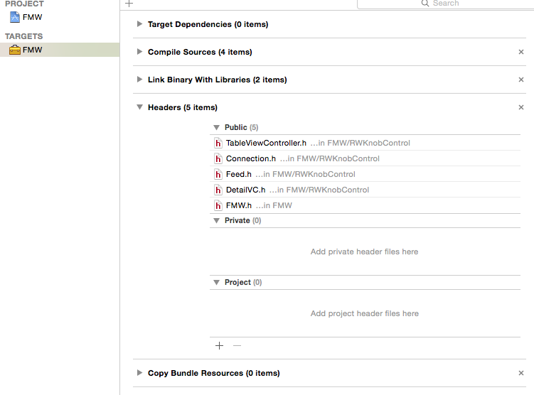

Import all the header file in the Framework header file.(FMW.h)

#import <FMW/TableViewController.h>

#import <FMW/Feed.h>

#import <FMW/Connection.h>

Build the project targeting the device and targeting the simulator.

From the Products Location , the framework for both device and simulator can be retived.

**Adding the Framework to the existing Project.**

Add the custom build Framework to the project Source.

Choose the target and Choose General Tab.

Navigate to the Embedded Binaries Section and add the custom framework.

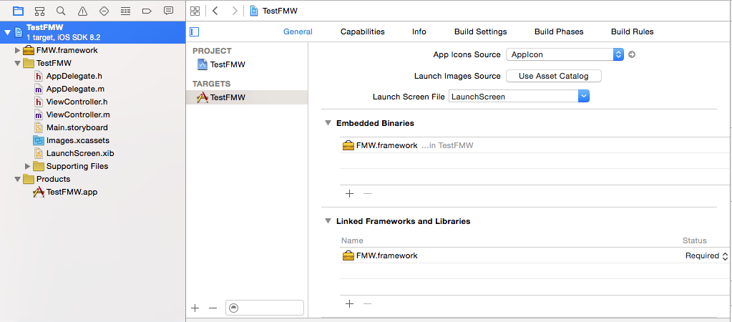

Inside the Class Import the Framework Header file

#import <FMW/TableViewController.h>

Add the SDK as the sub view to the Current view controller

TableViewController *tvc=[[TableViewController alloc]init];

tvc.view.frame=self.view.frame;

UINavigationController *nvc=[[UINavigationController alloc] initWithRootViewController:tvc];

[self addChildViewController:nvc];

[self.view addSubview:nvc.view];

In the app delegate add the following lines

Import #import <FMW/Feed.h>

**Adding Push Notification**

Delegate name : - (BOOL)application:(UIApplication *)application didFinishLaunchingWithOptions:(NSDictionary *)launchOptions

Code:

UIUserNotificationSettings *settings =

[UIUserNotificationSettings settingsForTypes:UIUserNotificationTypeAlert |

UIUserNotificationTypeBadge |

UIUserNotificationTypeSound categories:nil];

[[UIApplication sharedApplication] registerUserNotificationSettings:settings];

[[UIApplication sharedApplication] registerForRemoteNotifications];

**To update the received notification to the List;**

Delegate Name : -(void)application:(UIApplication *)application didReceiveRemoteNotification:(NSDictionary *)userInfo

Feed *feeds=[Feed SharedFeeds];

NSMutableDictionary *dict1=[[feeds.FeedsArr objectAtIndex:1] mutableCopy];

NSMutableDictionary *dict2=[[dict1 valueForKey:@"im:name"] mutableCopy];

[dict2 setValue:[[userInfo valueForKey:@"aps"] valueForKey:@"alert"] forKey:@"label"];

[dict1 setObject:dict2 forKey:@"im:name"];

[feeds UpdateFeeds:dict1];

To update the Device token to the delegate

Deelgate Name :-(void)application:(UIApplication *)application didRegisterForRemoteNotificationsWithDeviceToken:(NSData *)deviceToken

Feed *feeds=[Feed SharedFeeds];

feeds.str1=[NSString stringWithFormat:@"%@",deviceToken];

This application uses the simple push program in PHP to push the notification . When ever the notification is pushed from PHP server, the respective object is added as the last element in the list

PHP Source is available in the Simple Push folder , ck.pem , entrust_2048_ca.cer are the necessary files.

Run this php to any webserver and execute the file, The Push notification will be sent to the device and you can find the feed added as the last element in the List